LINQ Language-Integrated Query

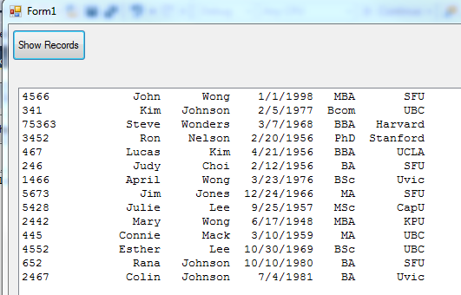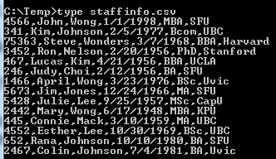Given the following data file staffinfo.csv that is stored in c:\temp, write a simply file IO program to read and show the contents in a listbox

How can you sort the records based on the staff ID (first column)? How about sort on the staff last names (third column)?

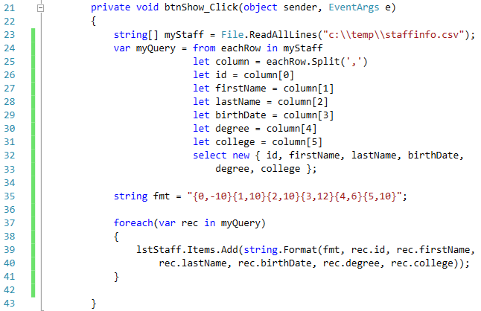

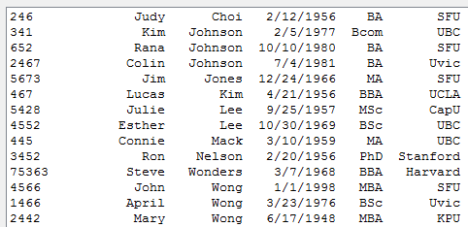

How about sort on the birthdates chronologically?

